**FUNCTION ON MACROS**

1. **Write a function to sort a given char array as a macro.**

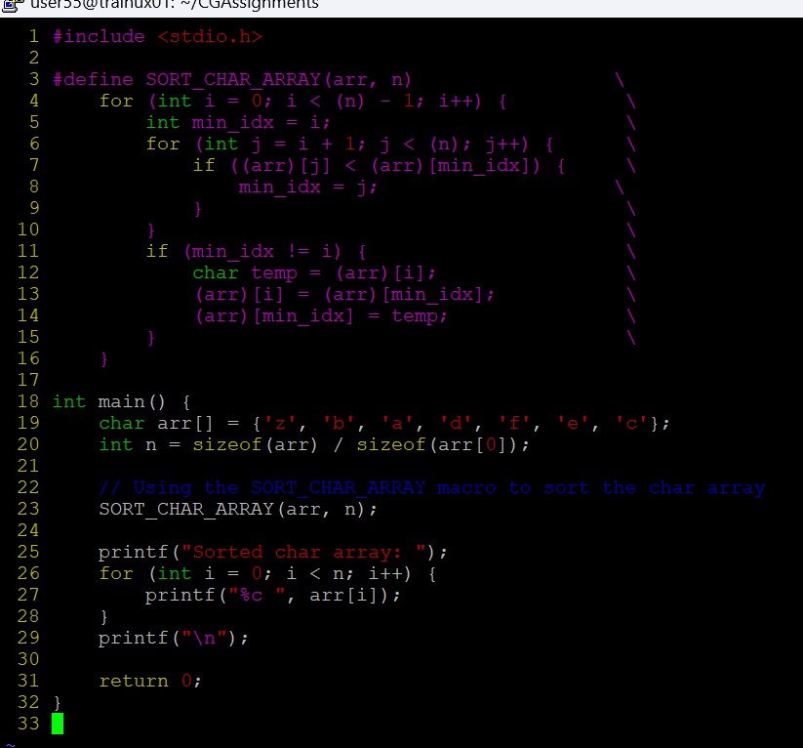

**OUTPUT:**

